 | Abdi İpekçi Caddesi Kaşıkçıoğlu Apt. No:42 D:2 34365 Nişantaşı İstanbul  www.artxist.com  info@artxist.com  T. +90 212 291 77 84 F. +90 212 343 69 35 | PRESS RELEASE

FANTASTIC 4

x-ist is pleased to host SENA’s fourth solo exhibition in Turkey, ‘Fantastic 4’ opening on October 20, 2011.

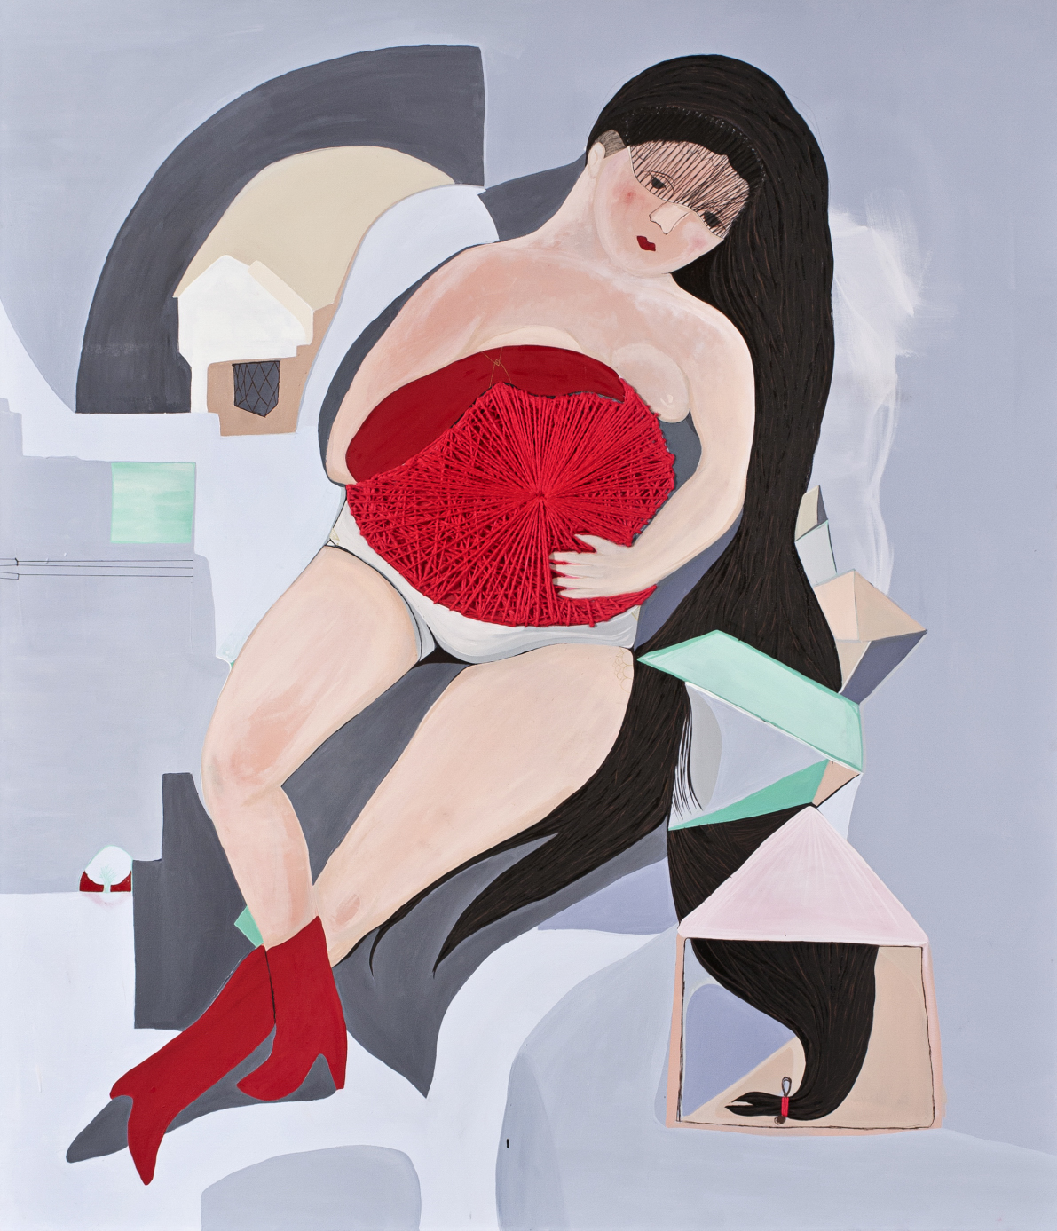

SENA, Romantic, oil on canvas, 210 x 180 cm, 2011

In her fourth solo show, SENA questions the issue of being a woman by making use of her observances and her own experiences, combining modern daily images through the use of symbols rooted in philosophy, mythology and religions. In her works, the artist breaks with established rules and rigid ideas through characters influenced by daily incidents and personal experiences. In this particular body of work, SENA turns her focus on the role of woman and her status in the prevalence of religious practices and the persistence of traditional cultural patterns while covering the symbolic expressions in the details of her works.
In the exhibition, Fantastic 4, women become symbols of power through their maternal abundance and fertility; they even become heroes. SENA challenges traditional stereotypes of women and presents a critical and realistic approach, a path which leads the audience to search for universal truths stripping away their own rigid ideas & practices and hence seeks to promote dialog and discussion. The exhibit can be seen till November 12, 2011 at x-ist.

SENA Istanbul, 1982
Sena graduated from London Central Saint Martins Arts College, Graphic Arts and Design Department in 2006. She worked on socially responsible art projects and exhibited her work in various areas of England and Istanbul. She is one of the two creators of ‘Tershane’ project started in 2006. Following her debut show titled 2 in 2009 in x-ist, she had her second solo show 3angle in 2010. Taking place in Contemporary Istanbul art fairs in 2006, 2007, 2008, 2009 and 2010. The artist also participated in Start-2009 (14th European Contemporary Art Fair, Strasbourg, France).

Ansen, Kayseri, 1978

Ansen studied painting at the Mimar Sinan Faculty of Fine Arts. He has had four solo exhibitions at x-ist between 2004 and 2009, x-ist-ence, Resistance, Menace, and The Trace. He participated in The Contemporary Istanbul 06, 07, 08 and 10, artfair06 Cologne, CIGE 08 – China International Gallery

